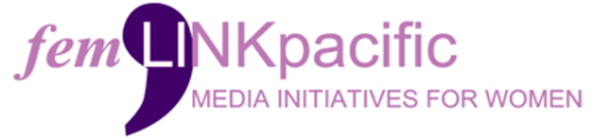

Join us at femLINKpacific.

We are a Pacific feminist media and policy network, that produces a range of media initiatives for and by diverse rural women. We own and operate femTALK Community Radio, FM89. We are based in Suva, Fiji and we also operate an office in Labasa. We support a thriving network of women to monitor and create media through our radio broadcasts, media networks and national and regional convening. We contribute to research on peace and security for transformative change.

Our success is seen in the movement building work that we conduct with various women-led, and women’s community-based organisations in Fiji and with them to our regional partners and collectives. We pride ourselves in being able to consistently and regularly convene local safe spaces for women in Fiji in all 4 administrative divisions (Central, West, North and recently East), and then bring these voices to a national platform, and in solidarity with our feminist partners and stakeholders, and thence and at times simultaneously move these within the region and at global platforms.

femLINKpacific has been awarded the Women’s Resilience to Disasters Grant through UN Women in the Pacific. As such a full time Project Officer is required.

The Project Officer reports to the Programmes Manager and supports the Management Team (MT) Collective in helping organize, implement and track the project implementation of the WRD activities.

The key responsibilities of the role include:
- Manage and implement the activities of the WRD project in collaboration with Programme Manager
- Timely submission of progress and narrative reports for WRD project
- Establishing and maintaining a strong relationship with stakeholders
- Support the project team in engaging with partners and resource organisations that would provide capacity support to partner organisations.
- Organise project and stakeholder meetings and coordinate the establishment and setting of agendas.
- Coordinate the logistical support for project implementation.
- Work closely with feminist media team to ensure WRD activity implementation are updated on the social media platforms in a timely manner

Key Qualification, Experience and Skills Required:
- Bachelor’s degree in business administration, management or any other relevant field.
- Minimum of five years of experience in project or programme management, information management, administration or related area is required
- Demonstrated capacity to work in a dynamic, fluid, feminist media organization with a vast diverse rural women’s network.
- Familiarity with the importance of feminist media and the amplification of the voices of a diverse rural women.
- Good time -management skills.
- Able to work as part of a team as well as with minimum supervision
- Good interpersonal and professional communication skills.
- Financial awareness
- Good analytical and reporting skills.
- Ability to travel within the established 14 Districts of femLINKpacific in rural, remote and urban locations in Fiji
- Able to work well under pressure.
Application Process:

Applications close on 26th April 2024.

Please submit your resume and cover letter detailing your experience on how you meet the requirements of this role to info@femlinkpacific.com. For more information about this role please reach out to our Programme Manager, Email: elesi@femlinkpacific.com.

Only shortlisted candidates will be contacted. For more information about femLINKpacific visit: www.femlinkpacific.org.fj

